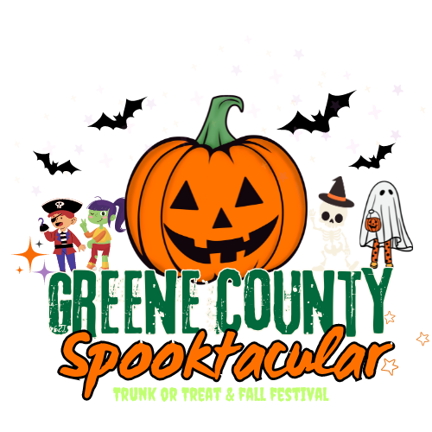

County of Greene, Virginia
Greene County Spooktacular
Friday, October 16, 2026
(Rain Date: October 23, 2026)
Car/Truck Vendor Form

Questions? Please contact Greene County Parks & Recreation
at (434) 985-5226 or Ssweeny@gcva.us

Name of Organization/Business/Individual: Click or tap here to enter text.
Contact Name(s): Click or tap here to enter text.
Address: Click or tap here to enter text.
City: Click or tap here to enter text. Zip: Click or tap here to enter text.
Phone: Click or tap here to enter text.
Email: Click or tap here to enter text.
Vehicle Make/Model: Click or tap here to enter text.
Car/Truck Theme: Click or tap here to enter text.

Please sign below that you adhere to the following policies and event waiver:
- Only pre-packaged candy or treats approved.
- No violent displays
- All car trucks must be registered to participate. All trunk participants will receive confirmation with instructions prior to event.
- All car trunk displays and treats will be inspected before event begins.
- No electricity will be provided.
- An adult and/or parent must always be with their vehicle during the Trunk or Treat event for safety reasons.
- No political, religious, or personal advertising on candy wrappers will be allowed.
- Any photograph taken at or during the event of yourself, or vehicle, can be used for the County of Greene promotional purposes.

Please return this form no later than Mon, October 5…and do not forget to wear your costume!

Greene County does not provide medical coverage or insurance for individual participants. All medical insurance protection must be provided by the parents or participant. In the event of an emergency, I hereby give my consent for the event coordinators of the Community Trunk or Treat to arrange for medical treatment or Emergency Room treatment by a physician on staff. I also hereby give my consent and approval for my son/daughter/myself to participate in this activity sponsored by the County of Greene. I will not hold Department Personnel, Instructors, School Personnel or Volunteers responsible in case of accident or injury as a result of my/my child’s participation in this program. I understand the risks involved with this activity and know that my child is/I am physically able to participate in this program.

SIGNATURE: Click or tap here to enter text. DATE: Click or tap to enter a date.

